**DAILY ONLINE ACTIVITIES SUMMARY**

|  |  |  |  |  |  |  |  |
| --- | --- | --- | --- | --- | --- | --- | --- |
| **Date:** | **27/06/2020** | | | | **Name:** | **AKASH S** | |
| **Sem & Sec** | **4TH&A** | | | | **USN:** | **4AL18CS004** | |
| **Online Test Summary** | | | | | | | |
| **Subject** | | **DATA COMMUNICATION** | | | | | |
| **Max. Marks** | | **30** | | **Score** | | **22** | |
| **Certification Course Summary** | | | | | | | |
| **Course** | **COMPUTER VISION ESSENTIAL** | | | | | | |
| **Certificate Provider** | | | **GREAT LEARNING** | **Duration** | | | **5 HOURS** |
| **Coding Challenges** | | | | | | | |
| **Problem Statement 1:Write a C program to print kth digit** | | | | | | | |
| **Status: executed** | | | | | | | |
| **Uploaded the report in Github** | | | | **YES** | | | |
| **If yes Repository name** | | | | <https://github.com/akashacharya786/lockdown-c-coding>  **https://github.com/akashacharya786/lockdown-java-coding** | | | |
| **Uploaded the report in slack** | | | | **YES** | | | |

**Online Test Summary:** DC online test was scheduled from 11:30am to 12:00pm.The question were MCQ type There were 30 question 1 mark respectively duration is 30 minutes .The score I received was 22/30.

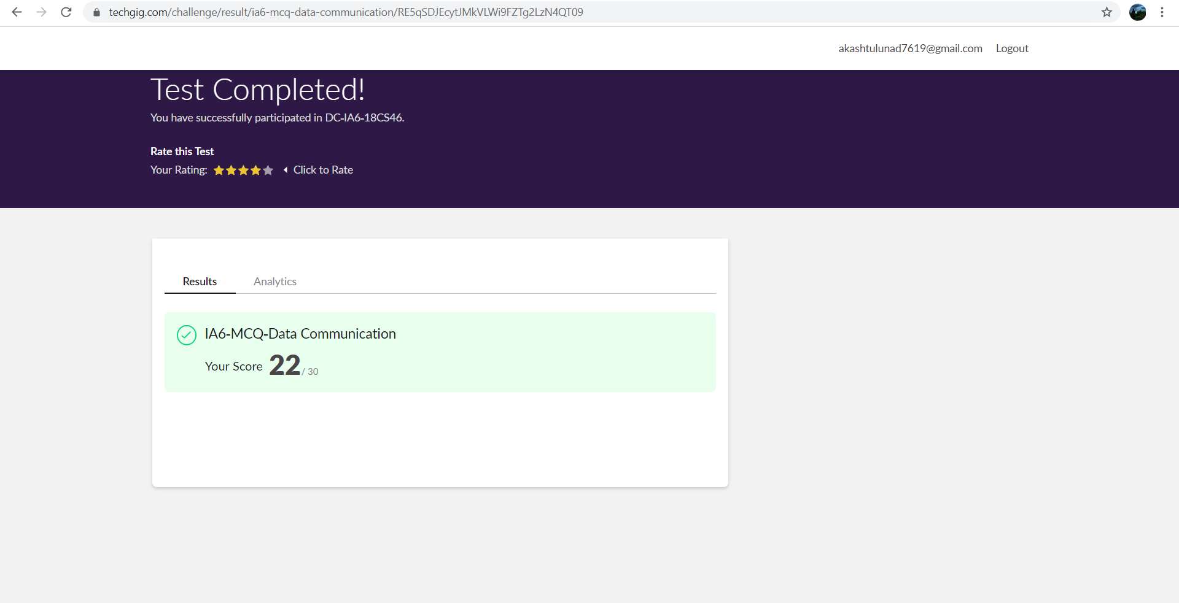

**Online Certification course:**

Name of the course :computer vision essential

Duration: 5 hours

Certificate provider: great learning

Today I have successfully completed all the chapter of the above course.

Snap shot:

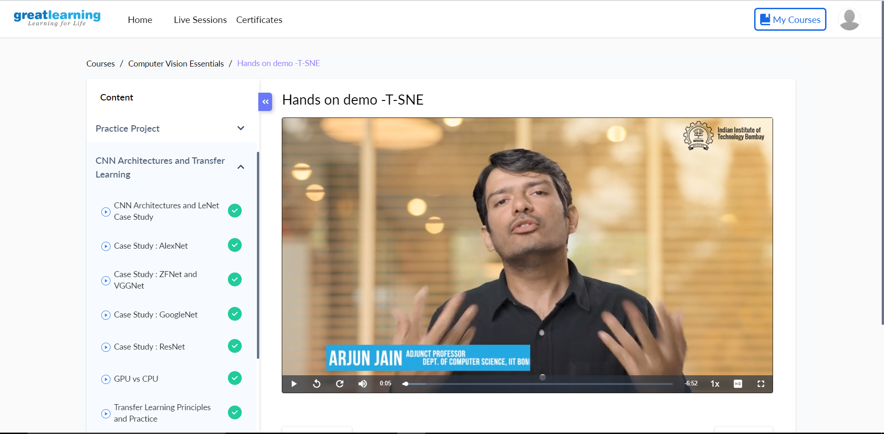

Online Coding summary:

**1. Write a C program to print kth digit**

**Snap shot:**

